JS (Part – 2)
- DOM manipulation
  - Document Object Model
  - Tree structure: node: element, text, attribute, comment
  - document.getElementById();
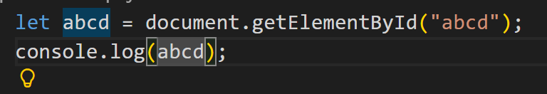
  - document.getElementsByClassName();
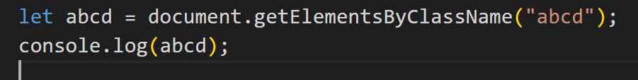
  - document.querySelector();
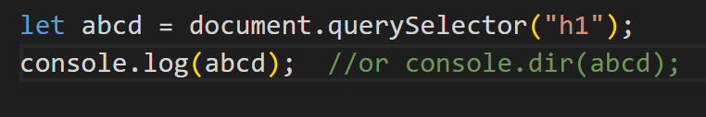
  - document.querySelectorAll();
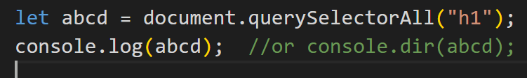
  - change hello world to hello suhas (innerHTML, innerText, textContent)
  - sometimes if console.log(); does not show DOM in console: use console.dir();
  - innerHTML: used to change html
  - innerText: used to change text
  - textContent: used to change text

- Attribute Manipulation (getAttribute, setAttribute, removeAttribute)
  - <a href=”” …….></a> // here href is attribute
  - 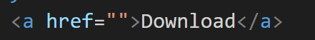
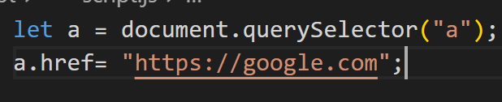
  - (Or) element.setAttribute(attribute name, attribute value);
  - 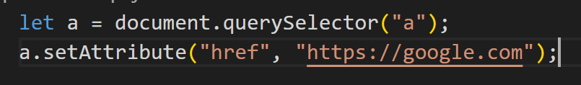
  - 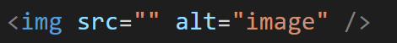
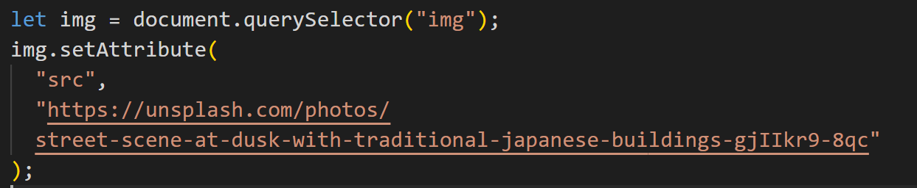
  - element.getAttribute(name);
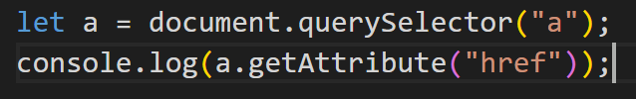
  - element.removeAttribute(name);
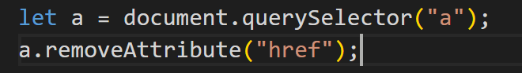

- Dynamic DOM manipulation (createElement, append, appendChild, remove, removeChild prepend)
  - Create element
  - Append/ prepend element
  - Append means after body it will show
  - Prepend means after body first only it will show eh: <h1> <a> = after appending <a>, it will become <a> <h1>
  - 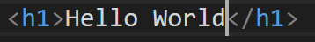
  - Append
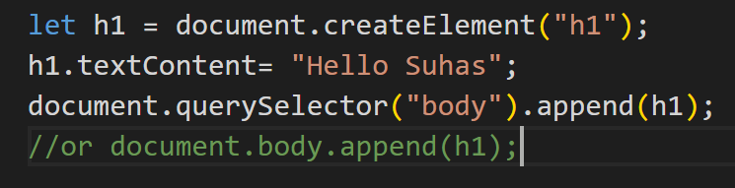

Output:
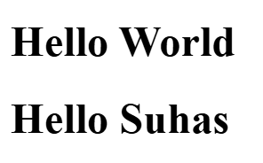
  - Prepend
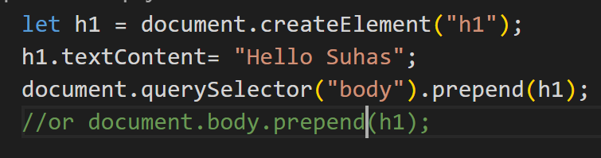
Output:
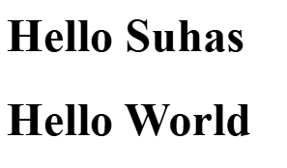
  - Remove();
Used to remove element in DOM

- Style (.style, classList (add, remove. Toggle)
  - We can change css and its styles & properties
  - 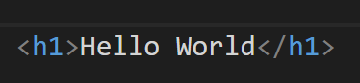
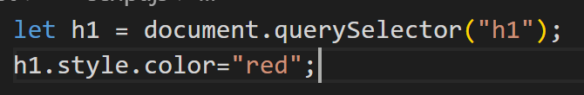
Output:

  - Using classList
    - 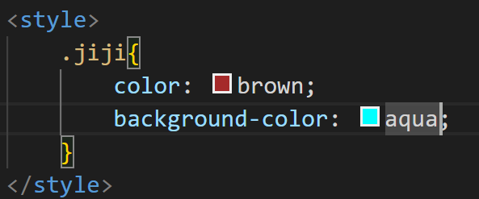
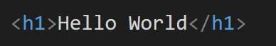
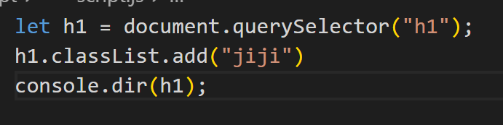
Output:

Remove is used to remove
Toggle is used to add if not added and is removed when it is added

- Events and events handling
  - Element.addEventListener(“event name”, function() { });
  - Click: (Single Click)
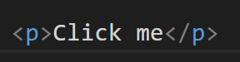
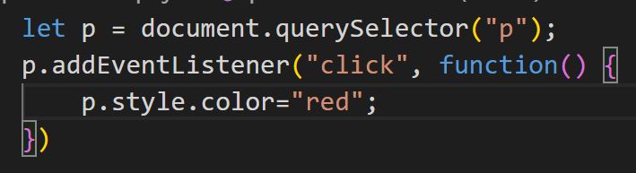
  - (Double Click)
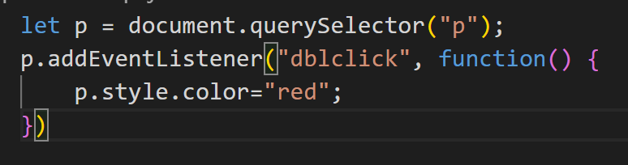
  - removeEventListener: is used to remove event added
  - input:
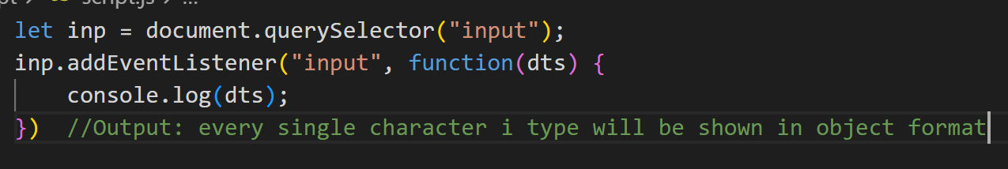
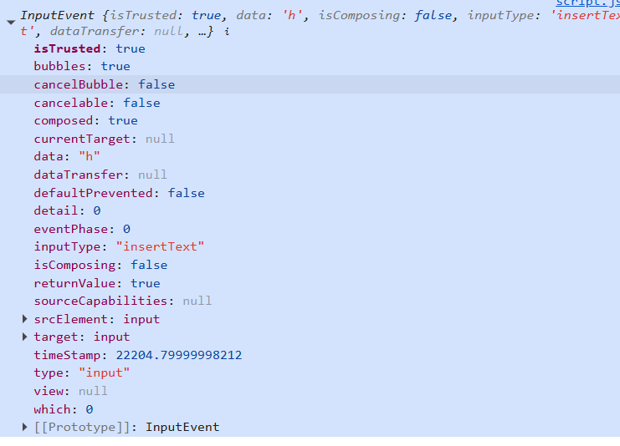
  - in this eg: backspace when I click it is showing null
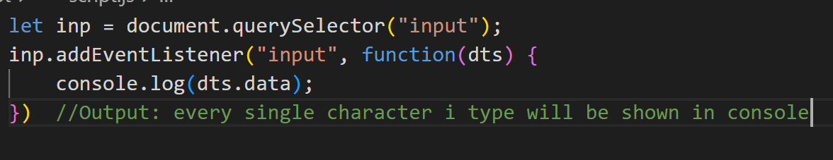
  - In this eg: when I click backspace it was showing null, after giving conditions, when I click backspace the data wont be showing as null
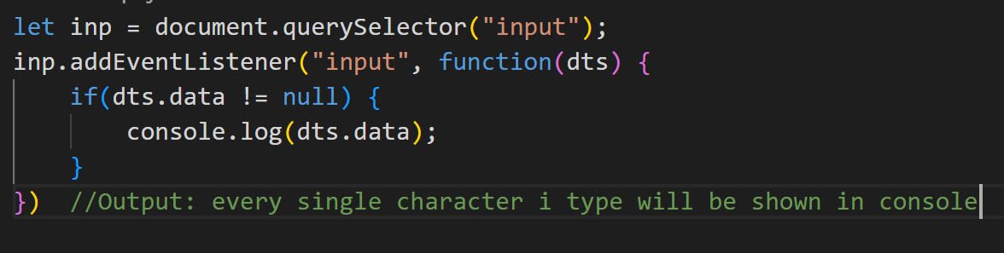
  - Change:
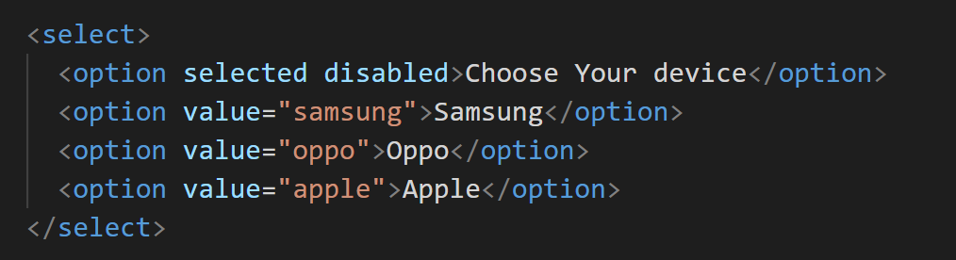
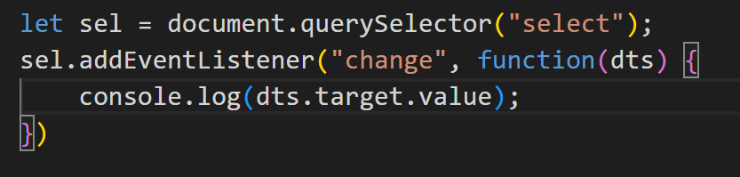
Output:
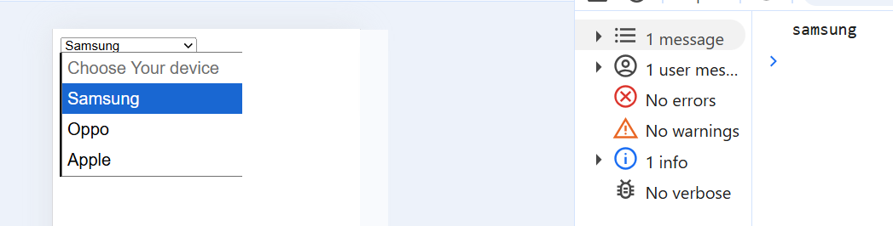
  - Eg: 1 => selected device should display in text dynamically
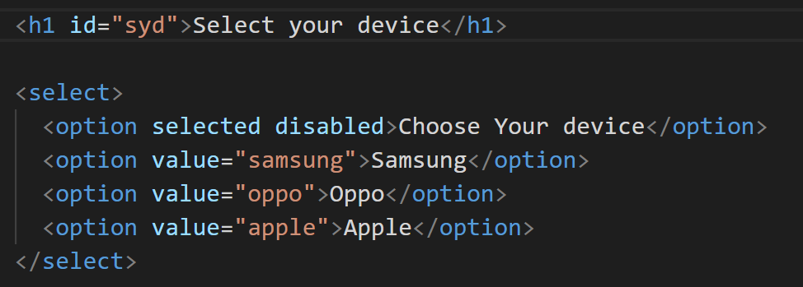
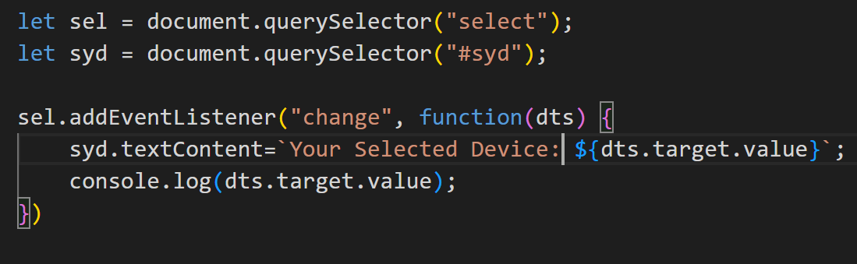
Output:
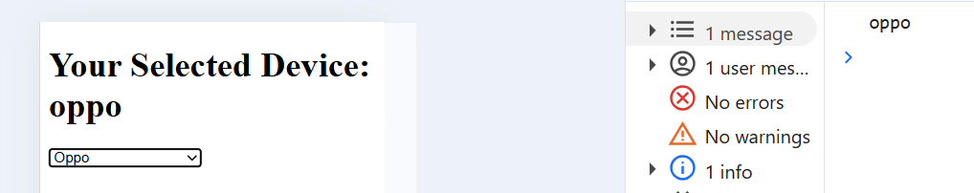
  - Keydown:
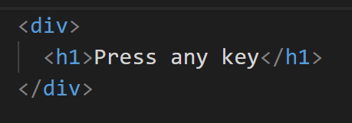
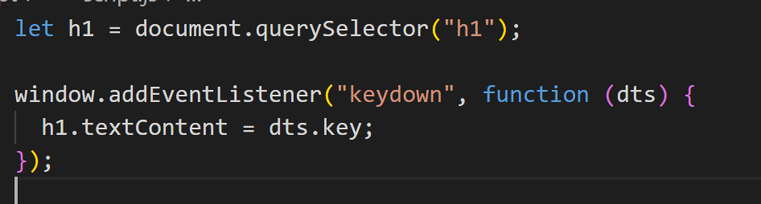
  - Submit:
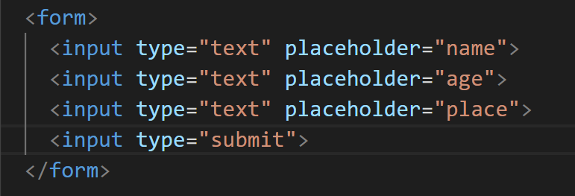
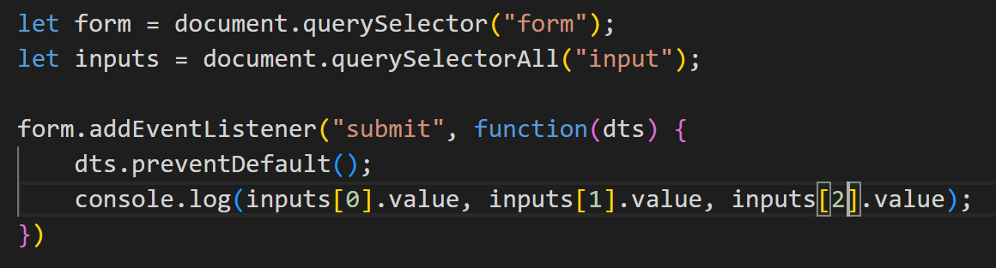
Output:
  - Eg: to show form values entered in screen
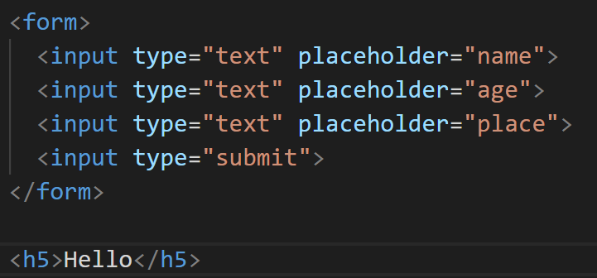
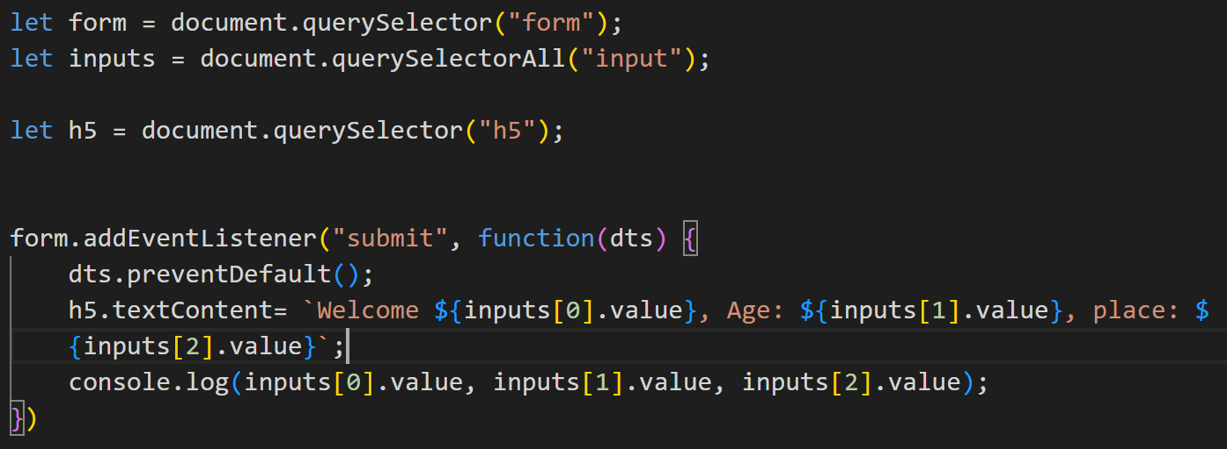
Output:
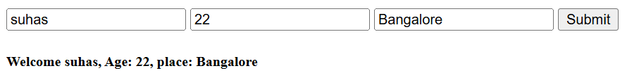
  - Eg: when I click on submit the values will be shown below in card and if I add more details , the other added details will also be added.
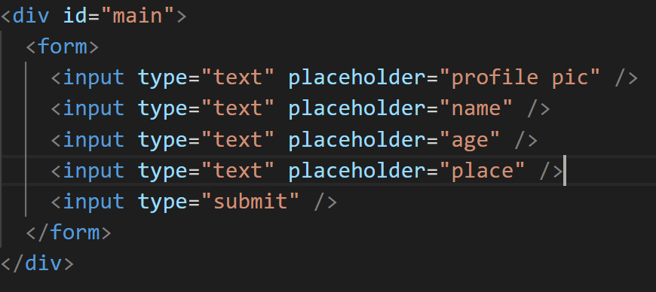

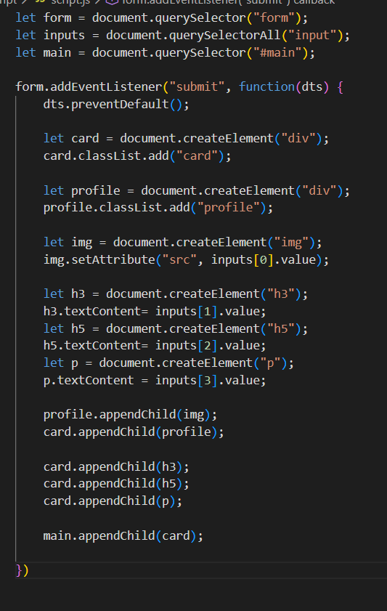

Output:
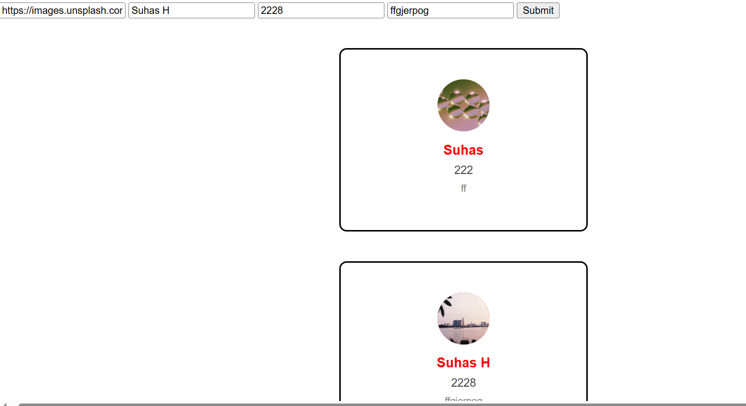
  - Mouseover: on hover
  - Mouseout: on hover out
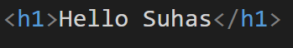
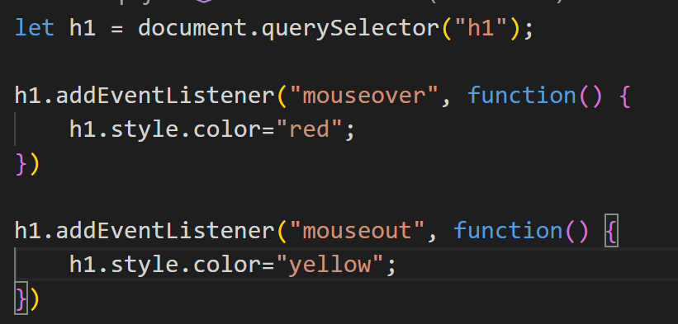
Output:
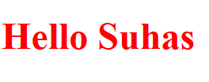

  - Mousemove:
  - Event object, type, target, preventDefault

- Event Bubbling
  - It searches for event listener, from child to parent.
  - If there is no event listener in child, and when child is clicked => it calls the parent event listener => if there is no event listener there also it will move to another parent event listener
  - Flow will be from bottom to top
- Event capturing
  - When the parent event event listener is clicked, it checks for true value in child event listener +. If it is present the event listener will execute and if child event listener has also has event listener => that will also executed also false value will be executed
  - Flow will be from top to bottom

- Forms and Form validation
  - If I don’t enter characters more than 1, it shows error
  - 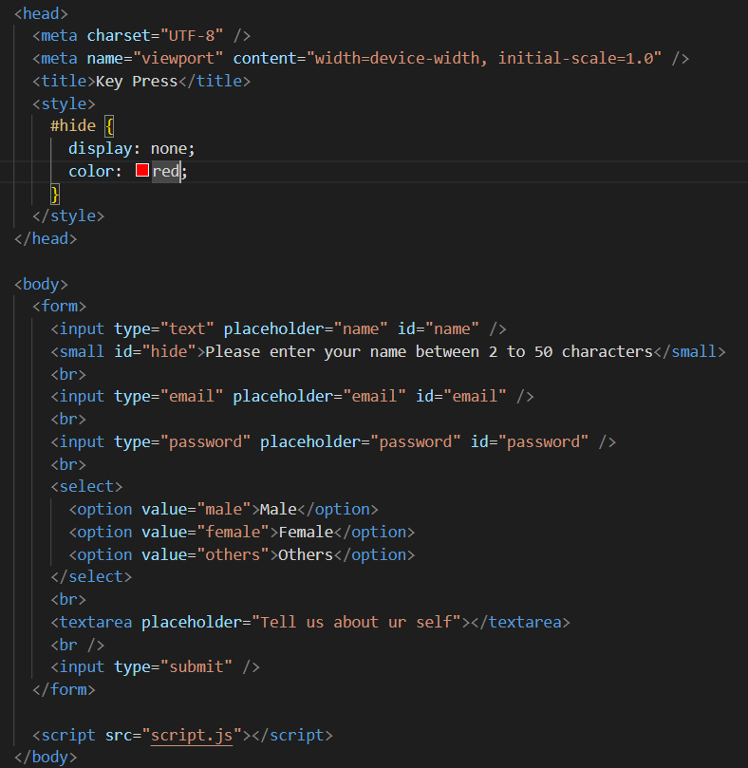
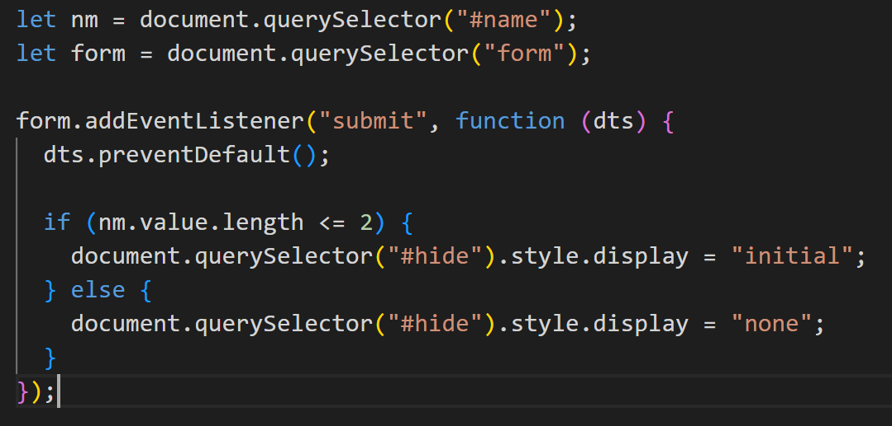
  - minLength, maxLength
  - pattern: “[a-z]{3,8}”
  - required
  - autocomplete
  - regex:
    - used to check email validation, phone, name etc
    - Returns true or false
  - 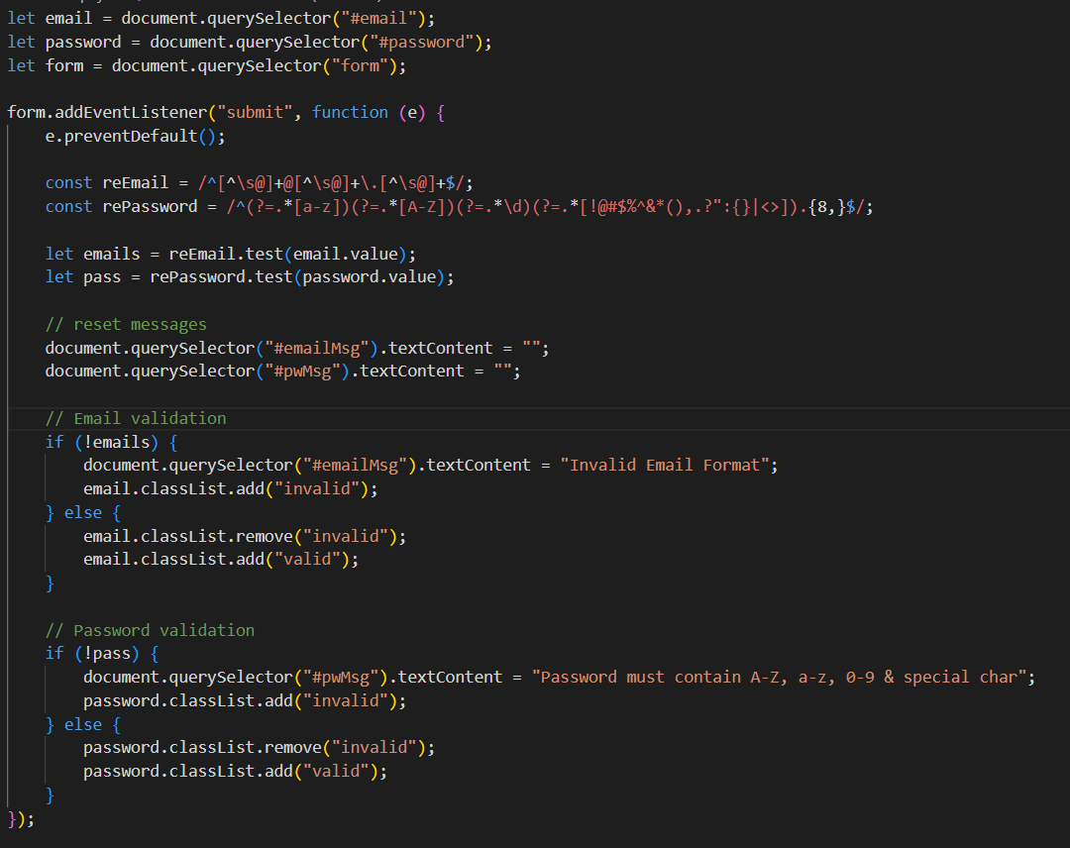
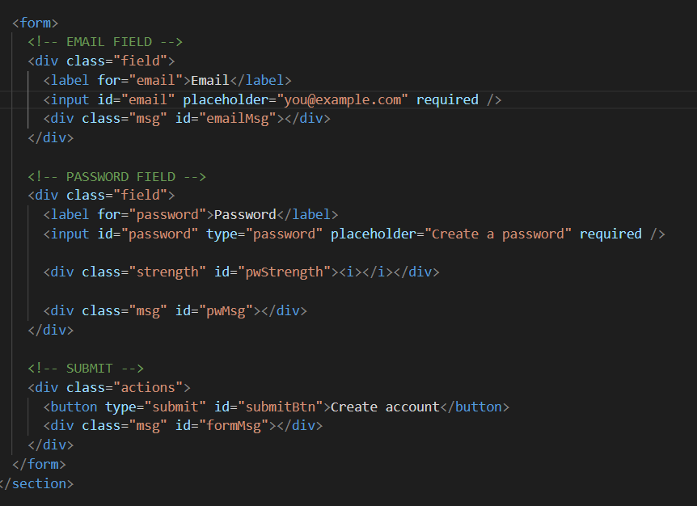
Ouput:
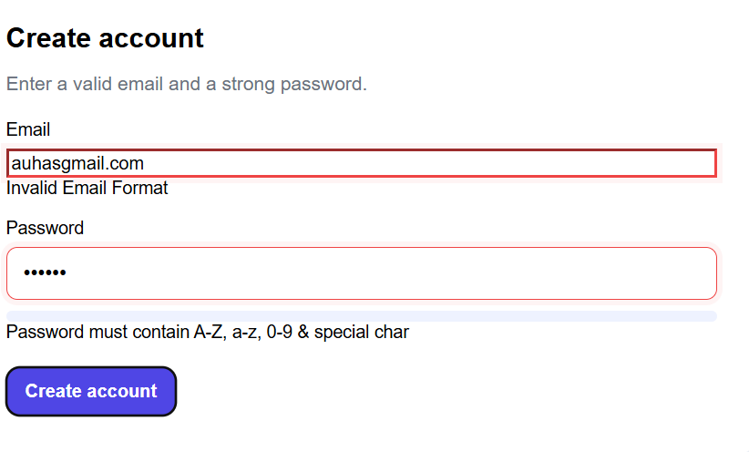

- Timers and intervals
  - setTimeout(function() {}, time value);
    - executes once
  - setInterval(function() {}, time value);
    - executes again and again
- clearInterval();
  - used to clear the interval
- 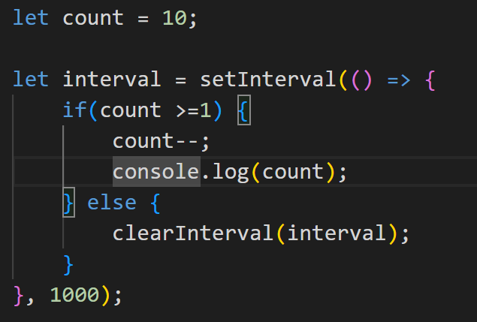
Output:
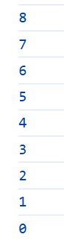

- Local storage, session storage
  - ~5MB
  - Set: localStorage.setItem(“name”, “Suhas”);
  - Get: localStorage.getItem(“name”);
  - Update: localStorage.setItem(“name”, “Hello”); //suhas to hello
  - Remove: localStorage.removeItem(“name”);

  - Set: sessionStorage.setItem(“name”, “Suhas”);
  - Get: sessionStorage.getItem(“name”);
  - Update: sessionStorage.setItem(“name”, “Hello”); //suhas to hello
  - Remove: sessionStorage.removeItem(“name”);

- Cookies
  - 4kb
  - Temporary small data
  - When reload, it goes to the server along with data and brings the data
  - document.cookie=”email=suhas@gmail.com”;

